**Task 8: Stored Procedures and Functions**

* **Stored Procedure:**

1. **Procedure to Insert New Employee**

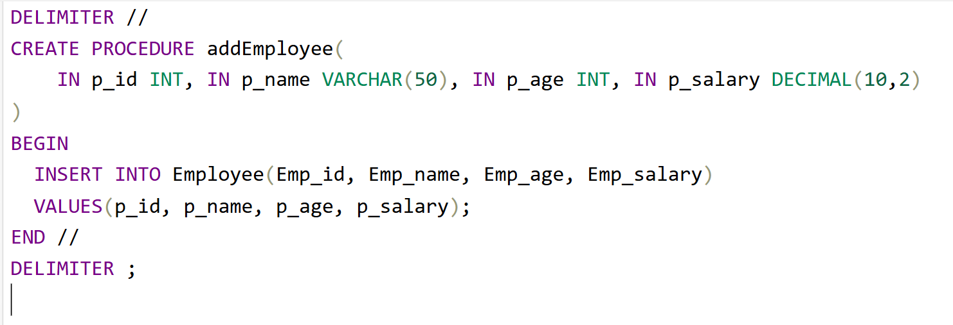

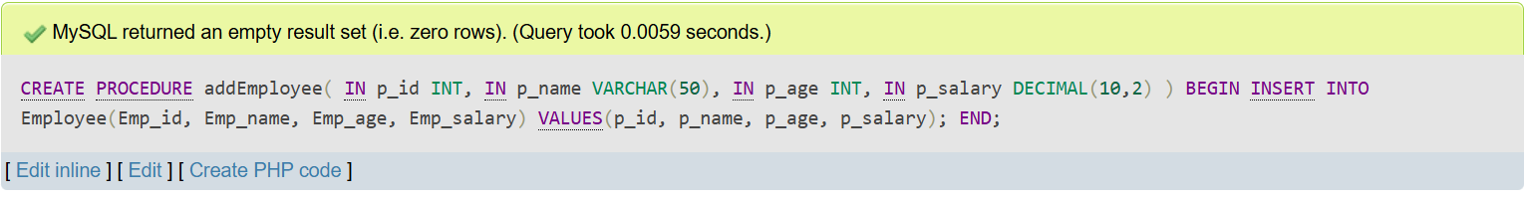**Output:**

1. 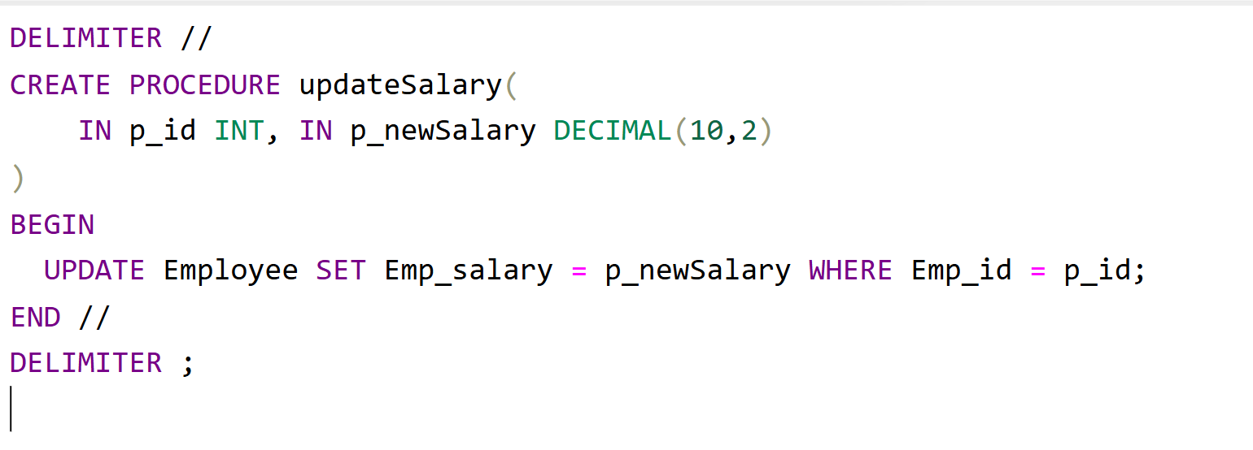**Procedure to Update Salary by ID**

**Output:**

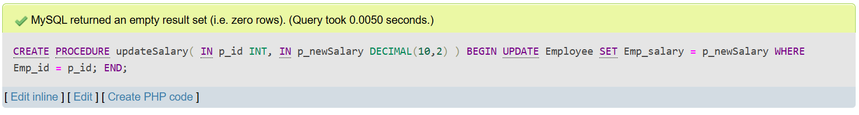

1. **Procedure to Delete Employee by ID**

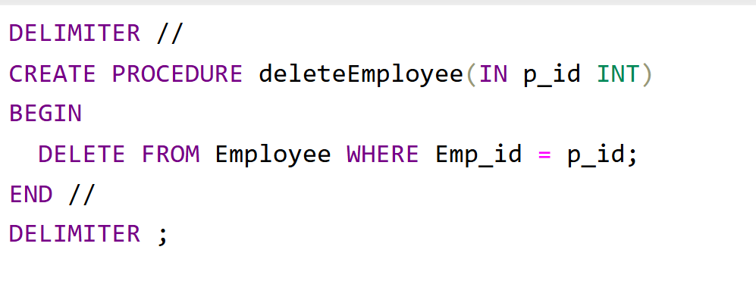

**Output:**

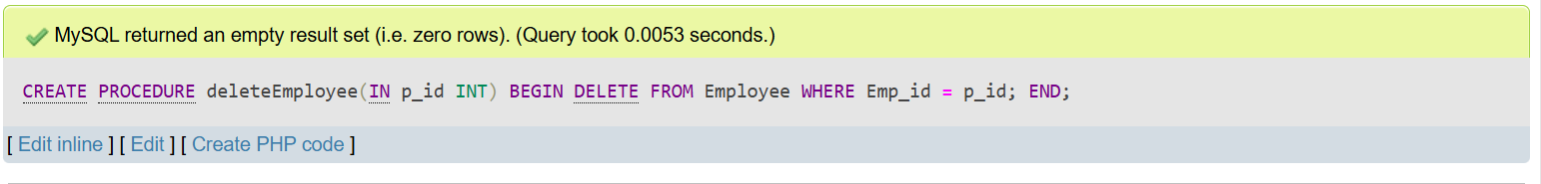

1. **Procedure to Display Employees with Salary Above Given Amount**

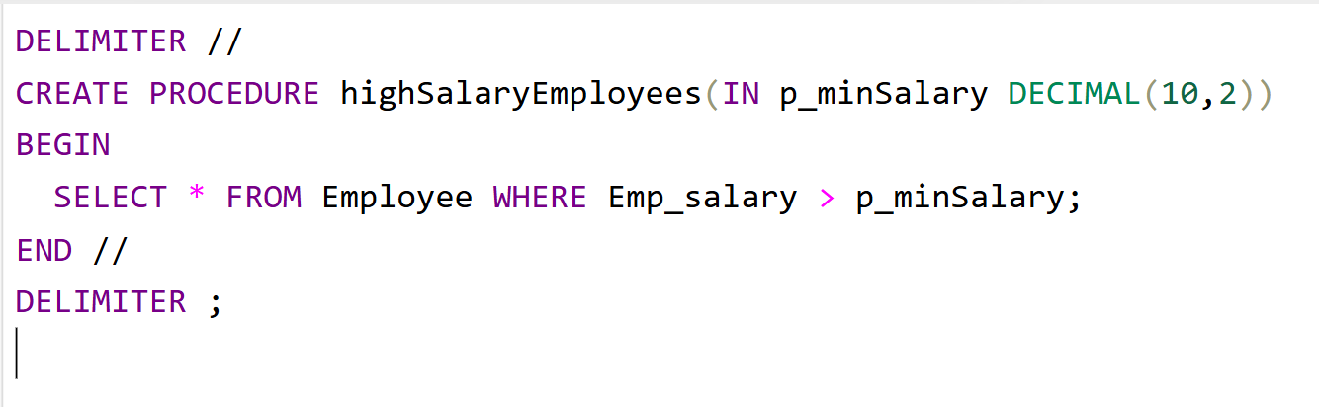

**Output:**

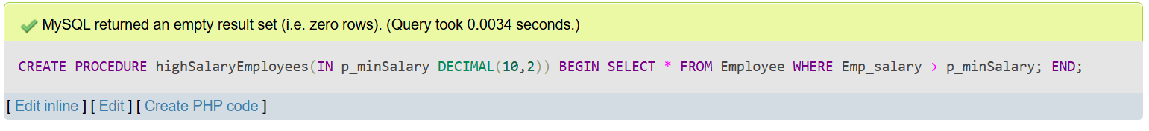

* **Function:**

1. 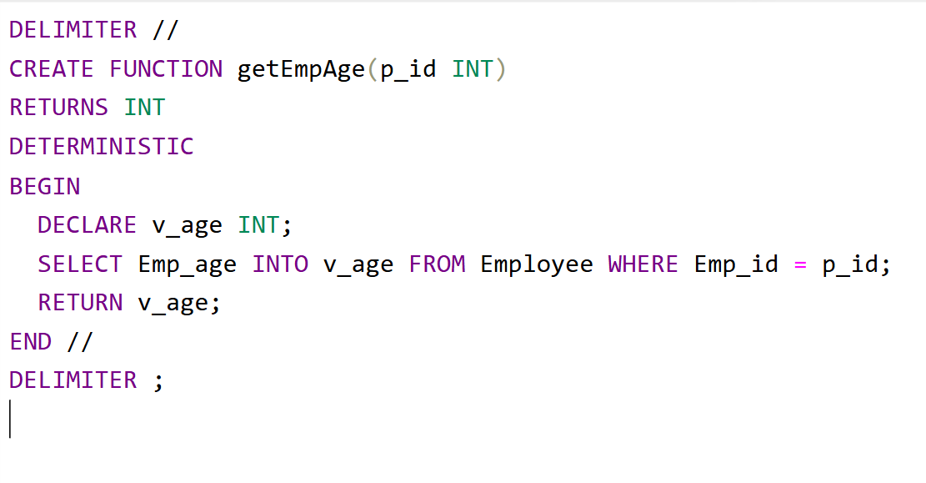**Function to Get Employee Age by ID**

**Output:**

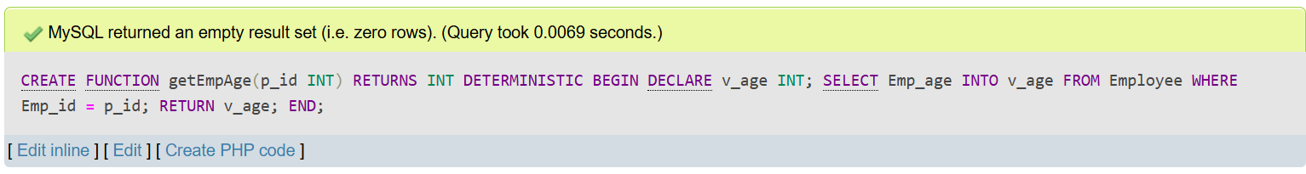

1. **Function to Calculate Annual Salary**

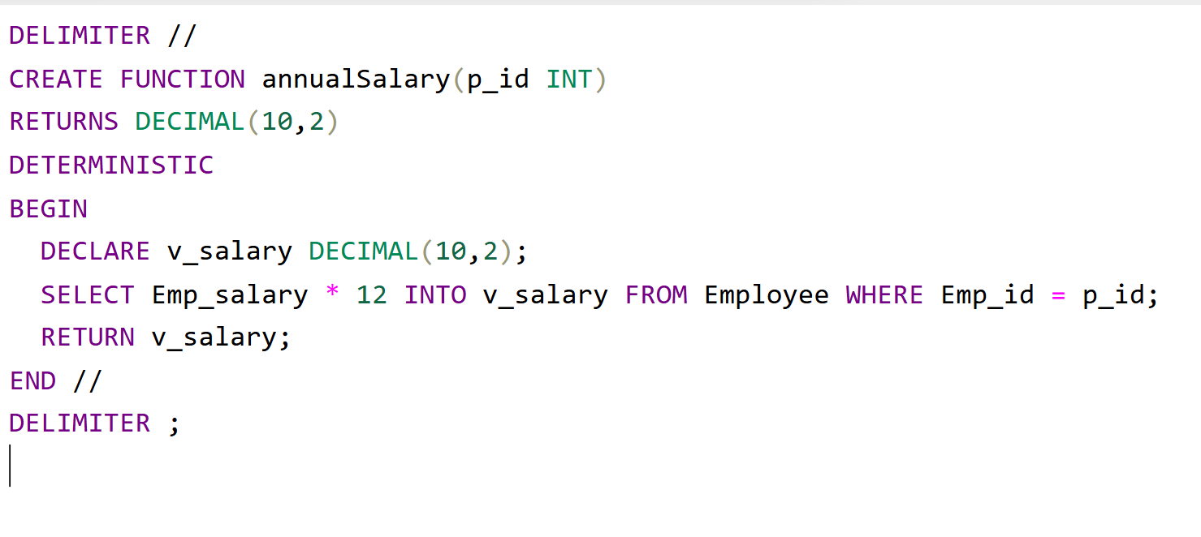

**Output:**

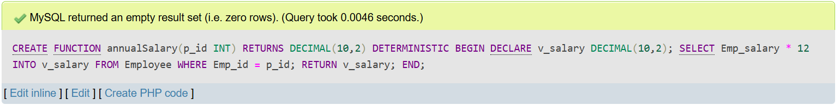

1. 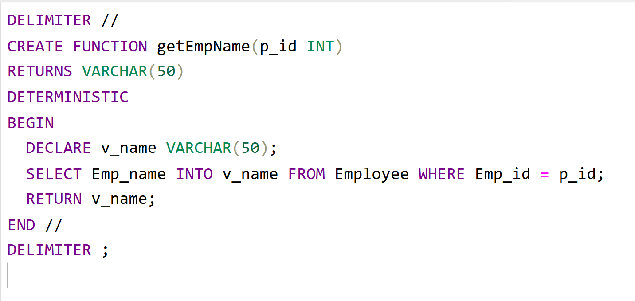**Function to Get Employee Name by ID**

**Output:**

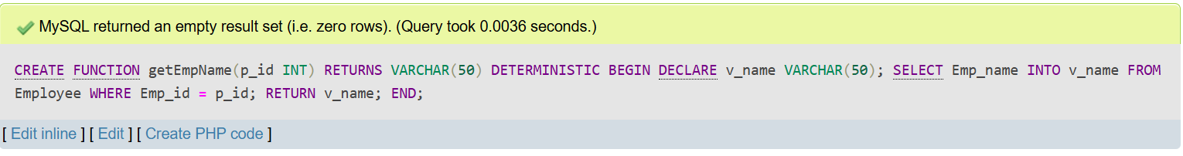

1. **Function to Check if Employee is Senior (Age > 40)**

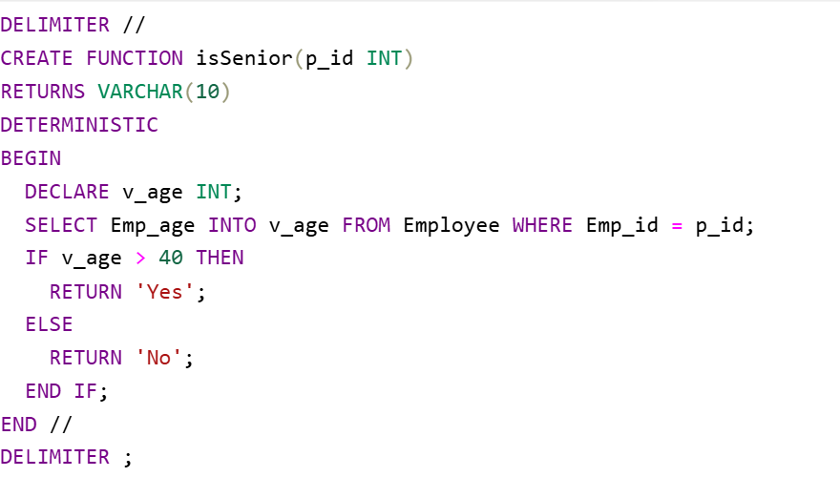

**Output:**

